Mathematical Foundations of Machine Learning
04 January 2024
https://www.udemy.com/course/machine-learning-data-science-foundations-masterclass/learn/lecture/23006968#overview

1. Introduction

2. What is Linear Algebra?

Segment 1: Data Structures for Algebra

What is Algebra?
Algebra is arithmetic that includes any non-numerical entities like x, e.g.

2x + 5 = 10

What is Linear Algebra?
If it has an exponential term then it isn’t linear algebra, e.g.

2x2 + 5 = 25
2√x + 5 = 25

Linear Algebra is “Solving for unknowns within a system of linear equations”

Consider the following example:

- Sheriff has 180 km/h car (2.5 km/min)
- Bank robber has 150 km/h car (3.0 km/min) and a five-minute head start
- How long does it take the sheriff to catch the robber
- What distance will they have travelled at that point
- Ignore, accelerations, traffic etc.

We could solve the problem graphically and determine when the two lines of distance vs. time cross, or we could solve the problem algebraically:

bank robber Eq1: d = 2.5t
sheriff Eq2: d = 3.0(t - 5)

2.5t = 3(t - 5)
2.5t = 3t - 15
2.5t - 3t = -15
-0.5t = -15
t = -15/-0.5 = 30mins
d = 2.5 * 30mins = 75 km

So in this neat and tidy case there is one solution.

However, there would have been no solution if the sheriffs car were the same speed as the bank robbers.

On the other hand, if the bank robber and the sheriff had cars that were the same speed AND, they set off at the same time, then there are an infinite number of solutions.

These are the ONLY THREE OPTIONS IN LINEAR ALGEBRA: one, non or infinite solutions.
It is impossible for the lines to cross multiple times - because they are linear.

In a given system of equations:

- There could be many equations
- There could be many unknown in each equation

This a regression model

y = house price ( we are trying to predict this)
x1 = distance to school
x2 = number of bedrooms

y = a + bx1 + cx2 +...+ mxm

m features - there could be many

a = y-intercept - he says without this it becomes very difficult to fit a good model?!

And there could be a very large number of rows, each time we examine another house and fit in the constants and the price we get another equation:

y1 = a + bx1,1 + cx1,2 +...+ mx1,m
y2 = a + bx2,1 + cx2,2 +...+ mx2,m
...
yn = a + bxn,1 + cxn,2 +...+ mxn,m

For many house i in the dataset,
yi = house price and xi,1 to xi,m are its “features”.
We say, “we solve” for the parameters a, b, c to m
i.e. given a set of equations with various as, bs, cs, etc. we want the solution - to predict the house price.

So we are trying to find a single value for a, b, c...m which suits ALL the rows in the set of equations at once.

So in machine learning terms, the xs are are inputs to the model, the ys are the outputs and a, b, c,...m are the weights and biases we want to find/train-to. And this is so we can use the trained weights/biases on unseen x values, to predict the unseen y values: house prices.

Contemporary applications of algebra
- Solving for unknowns in ML algorithms, including deep learning
- Reducing dimensionality (e.g. principle component analysis)
- Ranking results(e.g. with eigenvectors)
- Recommenders (e.g. singular value decomposition, SVD)
- Natural language processing (e.g., SVD, matrix factorization)
- Topic modelling
- Semantic analysis

3. Plotting a System of Linear Equations

So we get a little multi-modal at this point - go to

https://github.com/jonkrohn/ML-foundation

distance_robber = 2.5 * time_steps
distance_sheriff = 3 * (time_steps - 5)

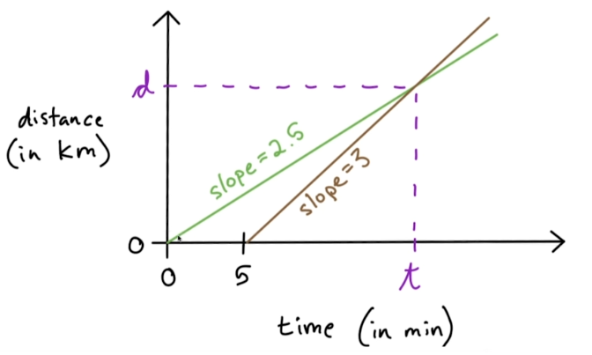

Go to 1:Intro to Linear Algebra
My version of the code see: S01L03_plotting_a_system.py

4. Linear Algebra Exercise
05 January 2024
start_x = -10
end_x = 10
num_points = 100
x_steps = np.linspace(start_x, end_x, num_points)
Energy generators:
- 01-04-2023 Mark I design starts 1 kJ/day
- 01-05-2023 Mark II design starts 4 kJ/day

Q1. On what day will Mark II have generated as much total energy as Mark I?
Q2. How much energy have both generated on that day?
Q3. What would the solutions to Q1. and Q2. be if the Mark II generated 1kJ of energy per day?

Graph of kJ vs. days

A1:
eq1: m1 = days * 1
eq2: m2 = (days - 30) * 4
when is m1 = m2?

days * 1 = (days - 30) * 4
days = 4*days - 120
days + 120 = 4days
days - 4days = -120
-3days = -120
days = -120/-3
days = 40 (from 1 April) = 10th May

A2:
Take either eq1 or eq2 and put in 40 days = 40 kJ

A3:
The two lines would be parallel so they would never meet - no solutions

5. Tensors

Tensors are a ML generalization of vectors and matrices to any number of dimensions.

Scalar x 0 dimensions Rank 0 Tensor

Vector 1 dimension Rank 1 Tensor

Matrix 2 dimensions

3-tensor 3 dimensions

etc.

6. Scalars

- 0 Dimensions
- Denoted in italics and in lower case x
- They should be typed, like other tensors, e.g. int, float32

https://github.com/jonkrohn/ML-foundations

Go to 1:Intro to Linear Algebra again
My version of the code see: S01L05_tensors1.py

7. Vectors and Vector Transpositions

My version of the code see: S01L05_tensors1.py

- 1 Dimensional arrays
- Rank 1 tensor
- Denoted by lowercase, italic, bold x
- Elements of a vector are scalars so not in bold
e.g. the second element of x is x2

We can think of them as representing a location in 2D space

Vector Transposition

T =

row vector column vector

computer says shape (3,) he says shape (1, 3)

computer says shape (3,) he says shape (3, 1)

8. Norms and Unit Vectors

Go to the code Lesson 7 in S01L07_norms_and_unit_vectors.py

With 1-dimensional vectors we can think of the value [12, 4] as:

- representing a point in 2D space
- representing a magnitude and direction from origin

Norms are a class of functions that allow us to quantify the magnitude (i.e. the length)
of a given vector.

The most common of the norm functions is the L2 norm function (“L two norm function”) described by
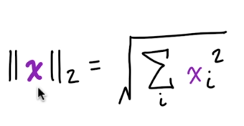

This measures the simple (Euclidean) distance from the origin.
It is so common that you can denote it without the subscript 2 -
i.e. as just ║x║

Do not confuse ║x║ with single lines either side of a x: |x| which means
the absolute value of x.

Go to code S01L08__norms_and_unit_vectors.py

=== Unit Vectors and other Norms ===

If ║x║ = 1 then x is a unit vector

Just to mention some other norms:

1. The L1 norm
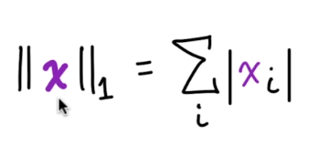

here we simply sum the absolute values of x and sum it.
- It grows linearly with x
- It is very good at distinguishing between zero and non zero

2. The L2 squared norm

x = [25, 2, 5]
normL2square = 25**2 + 2**2 + 5**2
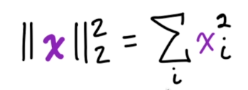

This is computationally cheaper than the L2 norm
L2 squared norm = x multiplied by its own transform xTx
- In L2squared, the derivative of an element x requires that element alone, whereas in L2 the whole vector is required.
- Downside is that L2squared grows very slowly near zero - so can’t be used if this is important.

Go to code S01L08__norms_and_unit_vectors.py

3. Max norm L infinity
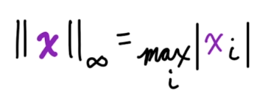

Return the absolute value of the largest magnitude element.

4. Finally Lp Norm
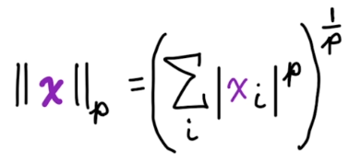

0. L2 norm p = 2
1. L1 norm p = 1
2. L2 squared norm ?
3. L infinity norm p = 0?

are all specific cases of L-p norm - just substitute in different values of p
Some constraints on p:
p must be
- a real number
- must be >= 1

Norms, particularly L1 and L2, are used for “regularizing” objective functions

9. Bases, Orthogonal, and Orthonormal Vectors

Basis Vectors
- Can be can be scaled to represent any vector in a given vector space
- For base vectors, we typically use unit vectors along the axes of the vector space

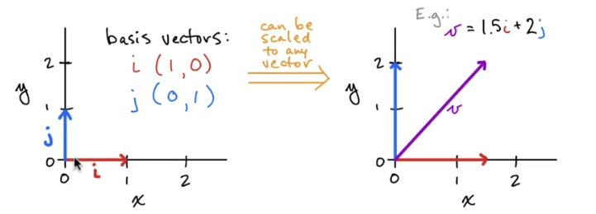

The basis vectors are i and j
So vector v (in the second diagram) can be described by scaling I and j and adding them together v = 1.5i + 2j.

Orthogonal Vectors
- x and y are orthogonal vectors if xTy = 0 (this is dot product)
- What the above means (assuming none-zero norms) is that x and y are at 90 degrees to one another - i.e. they are “orthogonal”
- In an n-dimensional space there can be at most n mutually orthogonal vectors.
e.g. in 2-D only (in a set of vectors?) there can be only 2 mutually orthogonal vectors.

An Orthonormal set of vectors are orthogonal and all have unit norm.
- Basis vectors are an example.

10. Matrix Tensors

A matrix is a two-dimensional array of numbers.
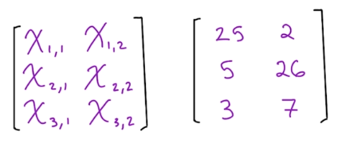

We denote matrices in uppercase, italic, bold, e.g. X
- vectors remember are lowercase, italic x
- scales are lowercase x

- Height is given priority over width in notation i.e. (n_rows, n_cols)
If X has 3 rows and 2 cols its shape is (3, 2)

- The individual, scalar elements of a matrix are denoted in uppercase, italics only.
- We can use a colon notation, to represent the entire row or column of a matrix
e.g. X:,1 is the entire left column of the matrix X

Go to code S01L08__norms_and_unit_vectors.py
section # 10. Tensors

11. Generic Tensor Notation

- Upper-case, bold, italics, sans serif, e.g., X
- In a 4-tensor, an element at position (i,j,k,l) would be denoted by X(i,j,k,l)

Go to code S01L08__norms_and_unit_vectors.py
section # 11. Generic Tensor Notation

e.g. a batch of colour images
32 colour, images, 28 by 28 pixels, 3 channels

12. Exercise on Algebraic Data Structures
OK
End of Section 1

=======================================================================
Section 2: Tensor Operations
=======================================================================
13. Section Intro

14. Tensor Transpositions

- 0 Rank Tensor - Scalar XT= X
The transpose of a scalar tensor is itself.

- 1 Rank - Vector - row vector to column vector and vice versa
T =

- Rank 2 Matrix transposition - we flip the axes across the main diagonal or swap the rows for columns

T =

(3,2)T = (2,3)

X(i,j)T = X(j,i)

Go to code S02L14_Tensor_Operations.py
14. Tensor Transpositions

15. Basic Tensor Arithmetic, including the Hadamard Product

Adding or multiplying with a scalar - operations occur to all elements, the tensor shape remains the same.

Go to code S02L14_Tensor_Operations.py
15. Basic Tensor Arithmetic, including the Hadamard Product

The Hadamard product or “element-wise” product
Notation A ⊙ X
If two tensors have the same size we can often apply the operator element by element
This is NOT matrix multiplication

A + B
A * B

16. Tensor Reduction

Calculating the sum across all the elements of a tensor is a common operation.
For example:

- For a vector x of length n, calculate:
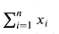

- For a matrix X of dimensions m by n, calculate:
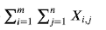

In addition to this is a relatively common requirement to calculate a reduction across only one of the dimensions:

(rows, cols)
rows is axis=0
cols is axis=1

X.sum(axis=0) means sum the three rows - leaving two results
shape (3,2) → (2,)

X.sum(axis=1) means sum the two cols - leaving three results
shape (3,2) → (3,)
===================================================
Code
This is difficult for me
===================================================
X = np.array([[25, 2], [5, 26], [3, 7]])
print(X)
print(X.shape)
"""
[[25 2]
[ 5 26]
[ 3 7]]
"""

# reduction across the rows (axis=0)
# means sum the three rows - leaving two results
# i.e. just reduce (squash) the row dimension to 0 (3, 2) -> (2,)
# i.e. reduce the dimension 0 to 0, leaving dimension 1
print(X.sum(axis=0))
print(X.sum(axis=0).shape)
"""
[33 35]
(2,)
"""

# reduction across down the cols (axis=1)
# means sum the two cols - leaving three results
# i.e. just reduce (squash) the col dimension to 0 (3,2) -> (3,)
# i.e. reduce the dimension 1 to 0, leaving the dimension 0
print(X.sum(axis=1))
print(X.sum(axis=1).shape)
"""
[27 31 10]
(3,)
"""

- You can do these reductions with other operators:

e.g.

- maximum
- minimum
- mean
- product

and you can do the reduction along a all or a selection axes

# If we had a batch of 100, 28 by 28 pixel RGB images shape
# X (100, 28, 28, 3) and we wanted to
# reduce them to grey scale would we X.sum(axis=3)? Not real y, but that is sort of the idea
# May be more like X.mean(axis=3)

17. The Dot Product

If we have two vectors of the same length, then we can calculate the dot product between them.
This is annotated in several different ways, including
x . y
x T Y
(x, y)

The first is the most usual.
The method is to calculate the product in an element-wise fashion and
then sum reductively across the product to a scalar value.

Go to code S02L14_Tensor_Operations.py
17. The Dot Product

# numpy
x = np.array([0, 1, 2])
y = np.array([25, 2, 5])

r = 25*0 + 1*2 + 2*5

18. Exercises on Tensor Operations
OK
19. Solving Linear Systems with Substitution

Solving linear Systems on paper

Method 1: Substitution
- Use whenever there is a variable in the system with a coefficient of 1

Q1: Solve for x and y
y = 3x
-5x + 2y = 2

so here, in eq1, y has a coefficient of 1 (i.e. 1*y == 1y == 1)
(by example the coefficient of x in Eq2 is -5)

- So here we substitute y in Eq2 for 3x

-5x + 2*3x = 2
so (x, y) = (2, 6)

Q2: Solve for x and y
x + y = 6
2x + 3y = 16

so y = 6 - x
so 2x + 3(6 - x) = 16
so 2x + 18 - 3x = 16
so 2x - 3x = -2
so -x = -2
so x = 2 and
y = 4 (x, y) = (2, 4)

Q3: can’t be bothered (x, y) = (-8, -2)
Q4: Solve for x and y (no solution)
y = 4x + 1
-4x + y = 2

so -4x + 4x + 1 = 2
so ? 1 = 2 (two parallel lines on a graph?)

20. Solving Linear Systems with Elimination

Method 2: Elimination
- Typically the best option if no variable in the system has coefficient of 1
- Use the “addition” property of equations to eliminate variables.
- If necessary, multiply one or both equations to make elimination of a variable possible.

Q1: Solve for the unknowns in the following system:
Eq1: 2x - 3y = 15
Eq2: 4x + 10y = 14

so … by multiplying Eq1 by -2 we get
Eq1: -4x + 6y = -30
Eq2: 4x + 10y = 14

so add the Eq1 and Eq2 - the x’s cancel out
16y = -16
so y = -1 and x = 6 ∴ (x, y) = (6, -1)

Q2:
Eq1: 4x - 3y = 25
Eq2: -3x + 8y = 10

Get the x’s to cancel out by multiplying Eq1 by 3 and Eq2 by 4
Eq1: 12x - 9y = 75
Eq2: -12x + 32y = 40

so Eq1 + Eq2
23y = 115
so y = 5, x = 10 ∴ (x, y) = (10, 5)

Q3:
Eq1: -9x -15y = -15
Eq2: 3x + 5y = -10

so multiply Eq2 by 3

Eq1: -9x -15y = -15
Eq2: 9x + 15y = -30

Eq1 + Eq2
0 = -45 - no solution

Q4: Eq1: 4x + 2y = 4
Eq2: -5x - 3y = -7

Eq1 * 3: 12x + 6y = 12
Eq2 * 2: -10x - 6y = -14

Eq1 + Eq2
2x = -2
x = -1 y = 4 ∴ (x, y) = (-1, 4)

21. Visualizing Linear Systems
Go to code S02L14_Tensor_Operations.py

=======================================================================
Section 3: Matrix Properties
=======================================================================
22. Section Intro
10 January 2023
23. The Frobenius Norm

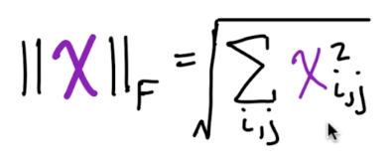

Consider each of the individual elements in X individually,
Go through all of the elements in the matrix, square them, and then sum them up and then square root the sum.

- Analogous to the L2 norm for a vector
- Measures the Euclidean size of a matrix

Go to code S03L22_Matrix_Properties.py

24. Matrix Multiplication

Very important...OK!

The number of cols in the first matrix A
has to be equal to the number of rows in the second matrix B

(rows, cols)
rows is axis=0
cols is axis=1

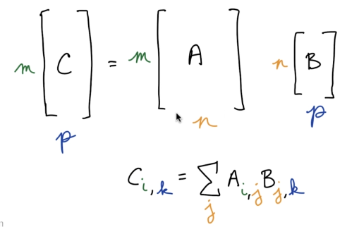

- You end up with a matrix that has the same number of rows as A and the same number of columns of B

- The dimension that was common to the two matrices, disappears.

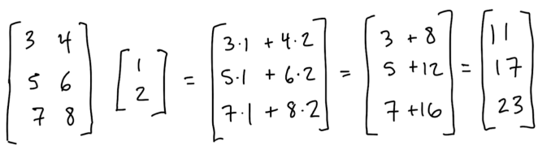

(3,2) * (2,) = (3,) (middle 2 have to be equal and cancel out)

(rows, cols)
rows is axis=0
cols is axis=1

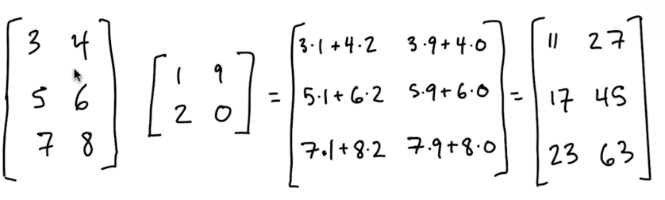

So (3,2) * (2,2) will give (3,2) (middle 2 have to be equal and cancel out)

Note that matrix multiplication is NOT commutative AB not equal to BA

Back to the example we first covered of house prices:

y1 = a + bx1,1 + cx1,2 +...+ mx1,m
y2 = a + bx2,1 + cx2,2 +...+ mx2,m
...
yn = a + bxn,1 + cxn,2 +...+ mxn,m
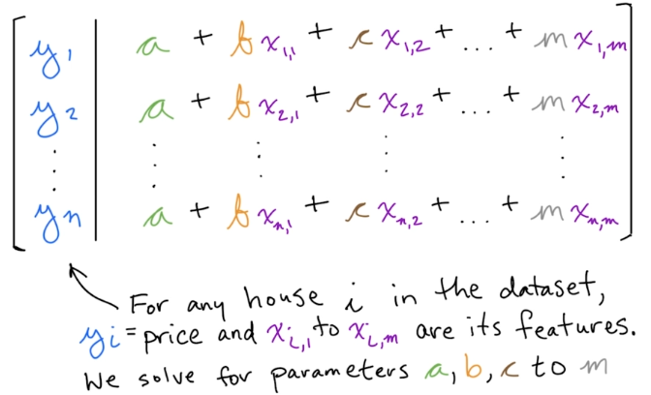

So we are trying to find a single value for a, b, c...m which suits ALL the rows in the set of equations at once.

“a” is the y-intercept or the average house price or something.

Rather than having a, b, c ...m repeated on every line, we can factor this out and it represented as a multiplication of two matrices:

Matrix Multiplication in Regression

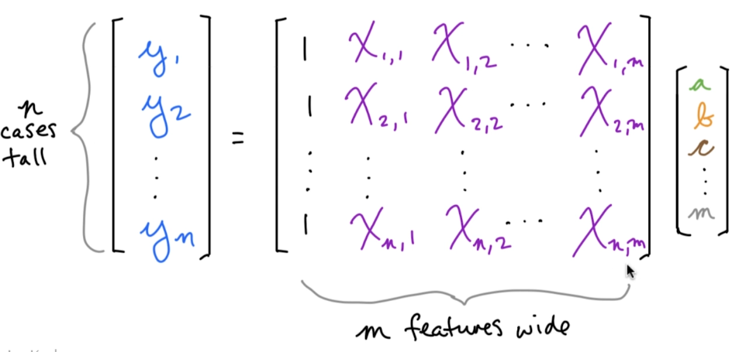

25. Symmetric and Identity Matrices
11 January 2024
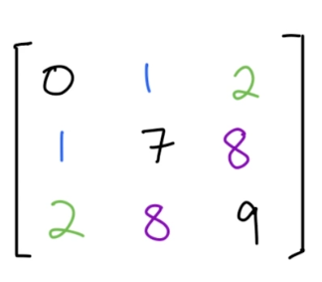

- A symmetric matrix has the following properties:
- Square
- XT = X

Go to S03L22_Matrix_Properties.py

A special case of a symmetric matrix is an identity matrix
An identity matrix is a symmetric matrix where:
- Every element along the leading diagonal is 1
- All other element are 0
- Notation is: In, where n = height (or width)

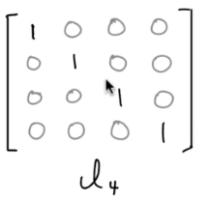

If you take an n-length vector w (in this example 4) and multiply it by In
it remains completely unchanged, i.e. w = wIn

Go to S03L22_Matrix_Properties.py

26. Matrix Multiplication Exercise

= =
(3,3) (3,1) = (3,1)

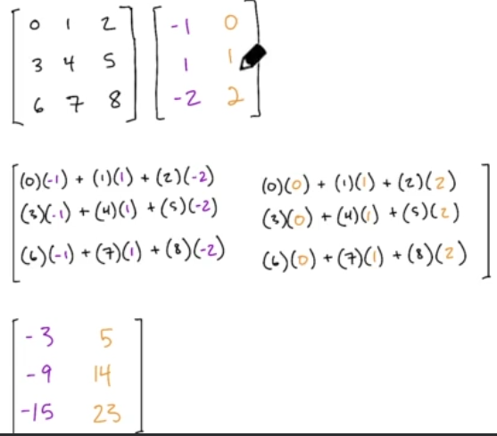

Tip on multiplication:
Note the pattern of colours
(3,3) (3,2) = (3,2)

27. Matrix Inversion
We do not cover how to get the matrix inversion here - this is later on.

Used to solve regression-style problems.

- This is a clever, convenient way of solving linier equations
- An alternative to manually solving with substitution, elimination etc.

- The matrix inverse of X is denoted as X-1
- Satisfies: XX-1 = In

Lets do an example:

The regression formula can be represented as:

y = Xw (where w is the vector of weights a, b, c...m)

yi = house price and xi,1 to xi,m are its “features”.
We say, we “solve for” the vector of feature weights a, b, c through m

Once again:

In the equation y = Xw

- We know the outcomes y, which are the house prices
- We know the features X, which are predictors of house prices like bedroom count
- Vector w contains the unknowns, the model’s learnable parameters

Assuming the matrix inverse X-1 does exist, matrix inversion can solve for the unknown w:

1) Xw = y
Multiply both sides of the equation by the inverse of X, X-1

2) X-1Xw = X-1y

So, because XX-1 = In we can say:

3) Inw = X-1y

And we know that w = wIn

So 4) w = X-1y - like dividing both side of 1) Xw = y by X

i.e. The weights vector = the inverse of the matrix * house price vector

Example:

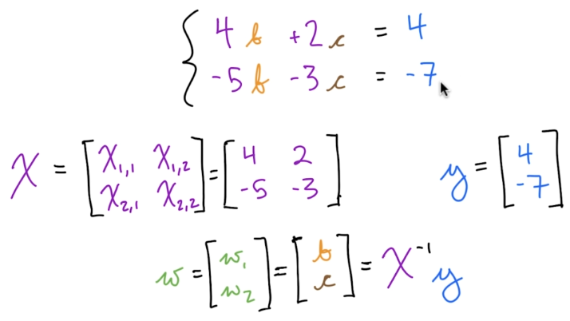

So, this is about as simple as it gets:

We are trying to solve for w (the weights) which are b and c

y = house prices =
X = the features (num bedrooms etc.) = =

w == = X-1y = (-1.0, 4.0)

Go to S03L22_Matrix_Properties.py 27. Matrix Inversion
END of PROOF

OK that’s all good.

Limitations for the Matrix Inversion method

Limitation 1:
A matrix can only be inverted if:

- The Matrix X is not “singular”, i.e. all of the columns of the matrix are be
“lineally independent”

e.g. 1. if X =
this would mean the lines have the same gradient and therefore never cross
i.e. no solution.

e.g. 2. if X =
this would mean they are the same line and there are an infinite many solutions.

Limitation 2:

Another limitation of matrix inversion, is that it can only be calculated if a matrix is square.

- A matrix is square if nrow = ncol (i.e., “vector span” = “matrix range”)
- vector span = nrow = number of equations
- matrix range = ncol = number of features aka dimensions in feature space

A) Square matrices avoid “overdetermination” nrow > ncol
Here, remember, each row in X is an equation and each col in X is a dimension in the feature space.

This is the usual situation - thousands of houses and house prices and (say) a dozen house features (dimensions in feature space)!

In this case there are many (or at least more than one) solutions to the set of linear equations - “so these numbers fit (4, -6, 4) and so do these numbers (2, 0, 3) or maybe this is the solution you are looking for...”
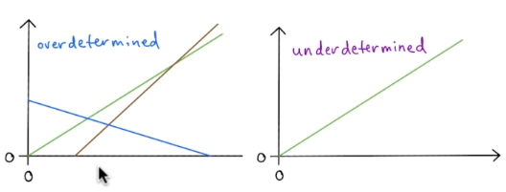

B) Square matrices also avoid “underdetermination” nrow < ncol
This might happen in deep learning where there are thousands of training data points but there are millions of parameters in the model.

Note: Solving the equations may still be possible by other means even if the matrix cannot be inverted.

Let’s do a code demo of trying to do a matrix inversion when there is no solution.

Go to S03L22_Matrix_Properties.py 27. Matrix Inversion

So this represents a system of two linear equations, one for each row, and two dimensions/features, one for each column, but not linearly independent

X = - square matrix, but not linearly independent

28. Diagonal Matrices

- A diagonal matrix is one that has non-zeros along the leading diagonal and zeros everywhere else.
- The identity matrix is a special case of a diagonal matrix, where every element along the leading diagonal is 1.
- Diagonal matrices DO NOT have to be square. This is due to the definition of “leading diagonal”. The leading diagonal starts at the top left had element of a matrix and proceeds down one, and along one until the boundary of the matrix

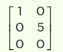
is an example of a non-square diagonal matrix.

- If the diagonal matrix is square, we can be denote it by diag(x) where x is the vector of its diagonal elements.

- Working with diagonal matrices is computationally efficient:

1. for multiplication: diag(x)y = x ⊙ y

2. Inversion diag(x)-1 = diag[1/x1,…,1/xn]T
The transpose is necessary where the diagonal matrix is not square.

Note: We can not divide by zero, so if the diagonal contains a zero then that diagonal matrix cannot be inverted

Non-square diagonal matraces can still be computationally efficient:
- if h > w, then add zero elements to the resultant product vector
- if w > h, then remove elements from the resultant product vector

29. Orthogonal Matrices

Alway square

- Recall orthonormal vectors - at right angles to one another (orthogonal) as well as having a unit norm.

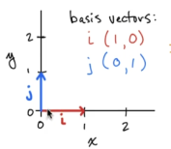

Basis vectors are a common form of orthonormal vector, but you can have orthonormal vectors that do not occur on the x or y axis and/or are rotated with regard to the axes.

In orthogonal matrices:

- orthogonal vectors make up all rows
- orthogonal vectors make up all columns

What does this mean?

Here are some examples and possible interpretations
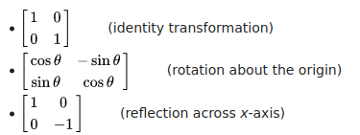

eg1

eg2

eg3

How to read orthogonal matrices as a set of vectors:

1. assume each row is a vector
2. label each column, from the left x, y, z,…,m and interpret them as axes

So in eg1 we have two vectors
(1, 0) x = 1, y = 0
(0, 1) x = 0, y = 1 (the identity matrix)
---------------------------------------
So in eg3 we have two vectors
(1, 0) x = 1, y = 0
(0, -1) x = 0, y = -1 (hence the reflection about the x-axis)
---------------------------------------

(0, 1) x = 0, y = 1
(1, 0) y = 1, x = 0
(reflection across x = y axis)
---------------------------------------

(1, 0, 0) x = 1, y = 0, z = 0
(0, 1, 0) x = 0, y = 1, z = 0
(0, 0, 1) x = 0, y = 0, z = 1
3D identity matrix
---------------------------------------

(1, 0, 0) x = 1, y = 0, z = 0
(0, 1, 0) x = 0, y = 1, z = 0
(0, 0, -1) x = 0, y = 0, z = -1
3D identity matrix reflected across x/y plane
---------------------------------------

(0, 1, 0) x = 0, y = 1, z = 0
(1, 0, 0) x = 1, y = 0, z = 0
(0, 0, 1) x = 0, y = 0, z = 1
Permutation of axes - but still an orthonormal matrix
---------------------------------------

Here are some results from the definition of an orthogonal matrix:

ATA = AAT = I

T =
. = yes - I’ve done this in code

Which also means:

eq1 AAT = I

divide eq1 by A

eq2 AT = A-1I = A-1

so eq3 A-1 = AT

For orthogonal matrices, the inverse of A = the transpose of A
This is great, because doing the transpose is very cheap computationally and dong the inverse is usually expensive.

30. Orthogonal Matrix Exercises
OK

=======================================================================
Section 4: Eigenvectors and Eigenvalues
=======================================================================
13 January 2024

31. Segment Intro

In this section we will use Tensors in Python to solve systems of equations and identify meaningful patters in data.

Lets quickly review what we have learned up to now: OK

They are called “regression” models because:

Francis Galton called it regression (toward the mean) because he'd modeled sons heights using their fathers height and noticed that sons height 'regresses' towards the mean in other words tall fathers tend to have shorter sons and conversely.

For example, if parents were very tall the children tended to be tall but shorter than their parents. If parents were very short the children tended to be short but taller than their parents were. This discovery he called "regression to the mean," with the word "regression" meaning to come back to.

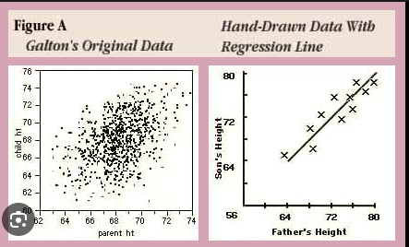

32. Applying Matrices
14 January 2034

What is it to “apply” one matrix to another?

Q1. Apply the identity matrix I3 to vector u
Q2. Apply the matrix B to vector u
Q3. Concatenate u to u2 to form matrix U, then apply the matrix B to the matrix U

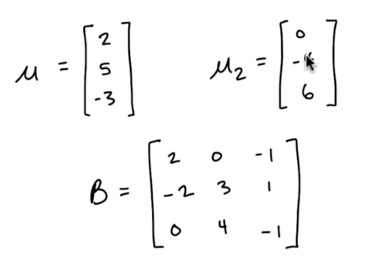

A key point here is that matrix multiplication is not commutative, so it matters which way around the matrices are multiplied.
I3
A1: If you “apply” matrix A to vector b,
it means you put A first in a multiplication with b thus: Ab

e.g. “I3 is applied to u” I3u

= =

(3,3) (3,) = (3,)

A2: Applied matrix first,Is Bu

(3,3) (3,) = (3,)

A3: Applied matrix first, Is BU

(3,3) (3,2) = (3,2)

33. Affine Transforms

Hand-on code demo - go to S04L33_Affine_Transformations.py

https://github.com/jonkrohn/ML-foundations
2: Linear Algebra II: Matrix Operations
Segment2: Eigendecomposition

Flip, rotate etc. by applying matrices.

“Applying” a matrix to a vector (i.e. performing matrix-vector multiplication) can linearly transform the vector, e.g. rotate it, scale it etc.

Applying an identity matrix does not transform the vector. - we know

Am affine transform can change geometry and may adjust distance or angles between vectors, bit it preserves parallelism between transformed vectors.

- A single matrix can apply multiple affine transforms

- In order to apply a transform to several vectors at once, we can concatenate the vectors into a matrix, where each column in that matrix is a separate vector. Then whatever linear transformations we apply to V will be independently applied to each column (vector)

34. Eigenvectors and Eigenvalues
16 January 2024

In the first case because the red vector and the blue vector retain their “direction” when flipped, they are eigenvectors. By direction we use the phrase “the same span” - Means something like “are along the same axis as before”

In the first case: the red vector and the blue vectors are eigenvectors of the flipping matrix.

First case:
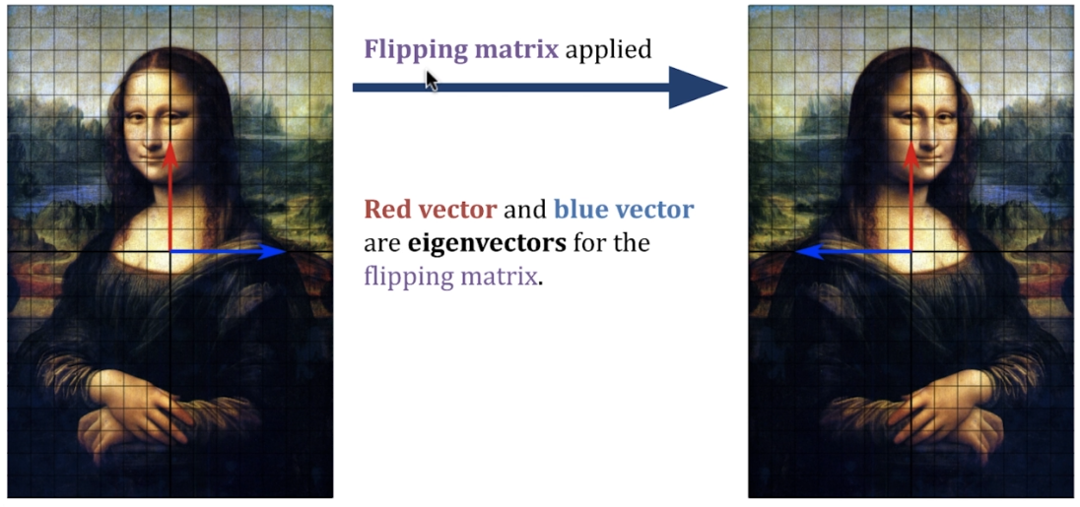

Second Case:
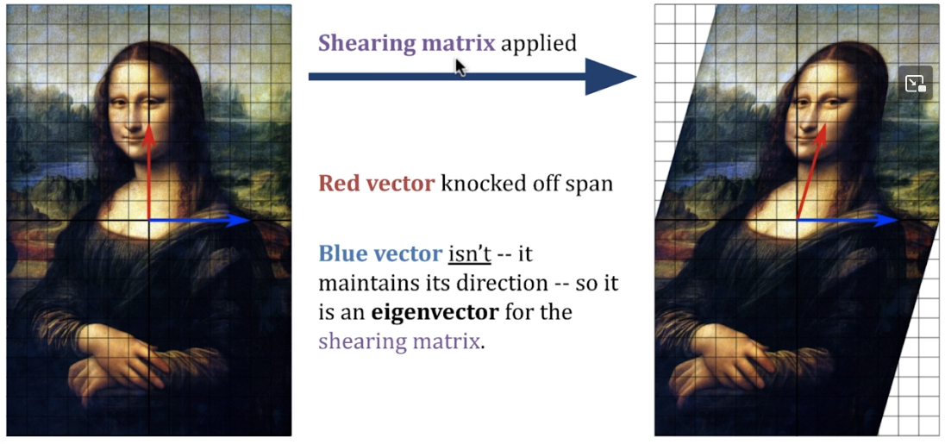

In the second case: we apply a different transformation - a sheer say - then in the blue vector is an eigenvector, but the red vector is not an eigenvector of the sheering matrix. We see that the red vector is “knocked off its span”.

Vectors that are not eigenvectors, do not have eigenvalues.?

Eigenvalues are scalar values, which tell you, how much the eigenvector has changed in length as a result of applying the matrix transformation. In the second case, the blue eigenvector has an eigenvalue = 1. If the eigenvector was doubled in length its eigenvalue = 2; if it were halved in length, then its eigenvalue would be 0.5.

Eigenvalues can also have negative sign. For example in the first case, the blue vector was flipped over, its eigenvalue is -1, and the red vector has eigenvalue 1.

Bit formal:

An eigenvector is a special vector v such that when it is transformed by some matrix (let’s say A), the product Av have the exact same direction as v. (or direct opposite as we saw in the Mona Lisa)

An eigenvalue is a scalar (traditionally represented by λ) that simply scales the eigenvector v, such that the following equation is satisfied:

Av = λv

Go to S04L34_Eigenvectors_and_Eigenvalues.py

Eigenvectors and eigenvalues can be derived algebraically but we cheat:

Here we use the numpy eig() method which returns a tuple of:

- a vector of eigenvalues
- a matrix of eigenvectors

Back from code demo

Eigenvectors in more than 2 dimensions - just the same

Go to S04L34_Eigenvectors_and_Eigenvalues.py

35. Matrix Determinants

A determinant is a special scalar value that we can calculate for any matrix.
It has an intimate relationship to eigenvalues.

Matrix Determinants
- Map a square matrix to a single, special scalar value
- Enable us to determine whether a matrix can be inverted

- For many matrix X, we denote its determiner as det(X)
- If det(X) = 0:
- The inverse X-1 cannot be calculated because (loosing it here)
X-1 would have determinant 1/det(X) = 1/0 = impossible

- The above indicates that the matrix X is singular
i.e. it contains linearly-dependant columns.

- This corresponds to the linear equations having no solution

The Determinant of a 2x2 Matrix
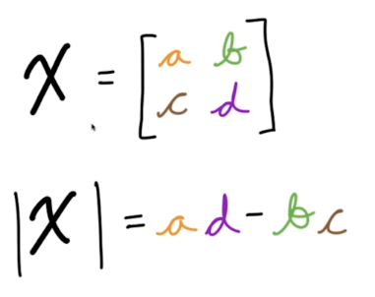

The bars either side of the determinant |X| do look like absolute value bars, but they are not - we are applying them to a matrix.

Go to S04L34_Eigenvectors_and_Eigenvalues.py
The 2x2 Matrix Determinant section

36. Determinants of Larger Matrices

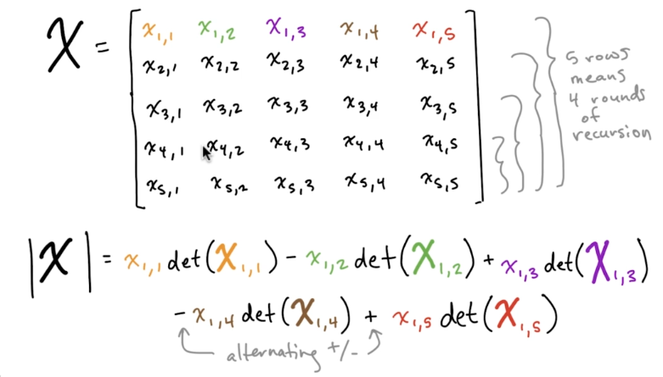

Using Recursion on a 3x3 example:
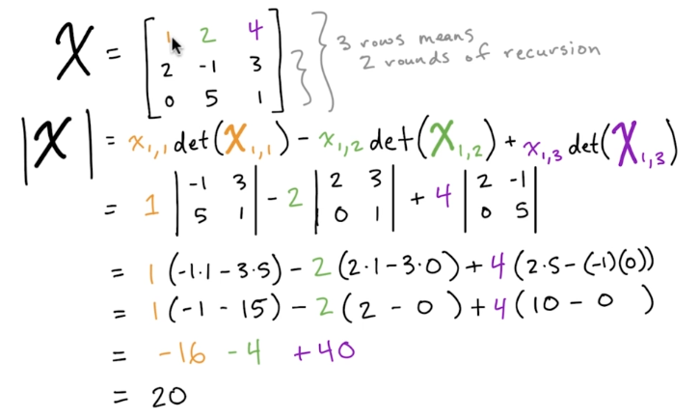

Go to S04L34_Eigenvectors_and_Eigenvalues.py
The Matrix Determinant greater than 2x2 section

37. Determinants Exercises

